**Research Paper Summary**

**Title:** Vision-based Vehicle Detection and Inter-Vehicle Distance Estimation

**Author(s):** Giseok Kim, Jae-Soo Cho

**Date:** 2012-09

**Link to paper:** <https://github.com/albud187/ELG5163_project/blob/main/literature%20review/finished_reading/Vision-based_vehicle_detection_and_inter-vehicle_distance_estimation.pdf>

Section 1 - Overall Idea

* Vision based system for vehicle detection and inter-vehicle distance estimation algorithm for driver assistance
* Edge detection / directional edge features / vehicle edge features + Haar-like features of car-rear shadows

Section 2 - Methodology

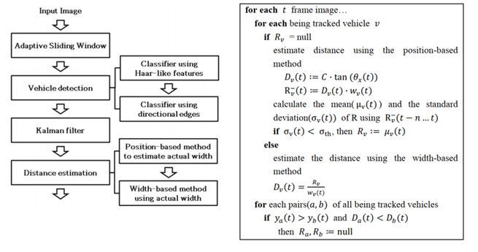

* Vehicle detection: find important features (haar-like features) + additional edge features of vehicles
* Kalman filter: refine detection + remove false positives
* Distance estimation: combine width-based estimation and position based distance estimation. For width based, need to know focal length an width of detected vehicle (but this isn’t always known). For position based - noise sensitive and assumes flat floor.

Section 3 - Applications

* Can be used as a local control method to control inter-vehicle spacing in platooning and formation control of land based mobile robots.

Section 4 - Future Development

* For width based method, it can be combined with an image classifier trained to identify make and model of vehicle and then compare to a database / data table for it’s width.

Section 5 - Questions

1. What about objects that are not or vehicles in general? What about motorcycles, bicycles or in general any other obstacle?

Section 6 - Anything Else

nil